**ITECH 7415 Assessment Task 2 Product Roadmap**

## Table of Content

Vision Statement 2

Product Backlog 2

User stories and Acceptance criteria 3

Product schedule 6

# Vision Statement

The main aim of this system is to remove the communication gap between the students and the staff and create an environment in which its easy to learn. The second goal of this project is to manage the reports of the student’s queries and teacher’s replies.

# Product Backlog

|  |  |  |  |
| --- | --- | --- | --- |
| **ID** | **User Story** | **Estimation (days)** | **Priority** |
| 1 | As an admin of the system, I want to sign in/sign out of the system. | 2 | 1 |
| 2 | As an admin of the system, I want to add/remove users in bulk. | 2 | 2 |
| 3 | As an admin of the system, I want to reset user password. | 1 | 3 |
| 4 | As an admin of the system, I want to edit/update user profile. | 3 | 4 |
| 5 | As an admin of system, I want to view/generate reports. | 4 | 5 |
| 6 | As a user(staff) of system, I want to sign in/sign out. | 2 | 6 |
| 7 | As a user(staff) of system, I want to reset my password. | 1 | 7 |
| 8 | As a user(staff) of system, I want to reply to student queries. | 4 | 11 |
| 9 | As a user(staff) of system, I want to send message to students. | 4 | 9 |
| 10 | As a user(staff) of the system, I want to set appointments to students. | 4 | 12 |
| 11 | As a user(staff) of the system, I want to view reports in graphic charts. | 4 | 14 |
| 12 | As a user(staff) of the system, I want to generate report weekly/monthly. | 4 | 15 |
| 13 | As a user(student) of the system, I want to sign in/sign out. | 2 | 16 |
| 14 | As a user(student) of the system, I want to reset my own password. | 1 | 8 |
| 15 | As a user(student) of the system, I want to send queries. | 4 | 10 |
| 16 | As a user(student) of the system, I want to see the replies to the queries. | 2 | 17 |
| 17 | As a user(student) of the system, I want to confirm appointment. | 2 | 13 |

This archive will be changed, refreshed and revamped by the client in collaboration with the project manager Sravanthi and the team. The unit for the measuring of time is days in this document.

# 

# User stories and Acceptance criteria

1. As an admin of the system, I want to sign in/sign out of the system.

Acceptance Criteria:

* Admin can sign into the system using email and password.
* Admin can sign out of the system.
* The signed in admin must land on admin dashboard.
* The signed in admin can navigate to users page.
* The signed in admin can navigate to the reports page.

1. As an admin of the system, I want to add/remove users in bulk.

Acceptance Criteria:

* Admin can sign into the system using email and password.
* Admin can navigate to the users page.
* Admin can view all the existing users.
* A new user can be added by providing the required details.
* Multiple users can be added by uploading a CSV file with details of users.
* Users can be deleted by clicking on the delete action.
* The deleted user must be removed from the table of users.

1. As an admin of the system, I want to reset user password.

Acceptance Criteria:

* Admin can sign into the system using email and password.
* Admin can navigate to the users page.
* Admin can reset a user’s password by clicking on the reset password action.
* The reset password must be updated in the database.

1. As an admin of the system, I want to reset user password.

Acceptance Criteria:

* Admin can sign into the system using email and password.
* Admin can navigate to the users page.
* Admin can edit a user’s profile by clicking on the edit action.
* The edited details must be updated in the users table.

1. As an admin of system, I want to view/generate reports.

Acceptance Criteria:

* Admin can sign into the system using email and password.
* Admin can navigate to reports page.
* Admin can view the reports of the queries weekly/monthly.
* Admin can generate new reports of the queries weekly/monthly.

1. As a user(staff) of system, I want to sign in/sign out.

Acceptance Criteria:

* User (staff) can sign into the system using email/password.
* User (staff) can sign out of the system.
* User (staff) signed into the system must land on the staff dashboard.

1. As a user(staff) of system, I want to reset my password.

Acceptance Criteria:

* User (staff) can sign into the system using email/password.
* User (staff) can navigate to reset password page.
* User(staff) can reset their own password to a new one.
* The changed password must be updated in the database.

1. As a user(staff) of system, I want to reply to student queries.

Acceptance Criteria:

* User (staff) can sign into the system using email/password.
* User (staff) can navigate to the queries page.
* User (staff) can see all the queries of the students.
* User (staff) can reply to the queries of the students.
* The reply of the queries must be sent to the associated student.

1. As a user(staff) of system, I want to send message to students.

Acceptance Criteria:

* User (staff) can sign in to the system using email/password.
* User (staff) can navigate to the messages page.
* User (staff) can send private message to the student they want, in the form of email.
* The message in the form of email must be delivered to the student’s email address.

1. As a user(staff) of the system, I want to set appointments to students.

Acceptance Criteria:

* User (staff) can sign in to the system using email/password.
* User (staff) can navigate to the appointments page.
* User (staff) can set an appointment to the student.
* The appointment must be shown to the appointments table of the student to confirm.
* An email of the appointment must be sent to inform the student about it.

1. As a user(staff) of the system, I want to view reports in graphic charts.

Acceptance Criteria:

* User (staff) can sign in to the system using email/password.
* User (staff) can navigate to the reports page.
* User (staff) can view the reports of the queries and appointments in the form of graphs/charts.
* The reports must include the correct statistics.

1. As a user(staff) of the system, I want to generate report weekly/monthly.

Acceptance Criteria:

* User (staff) can sign into the system using email/password.
* User (staff) can navigate to the reports page.
* User (staff) can generate a new report for a week/month.
* The report generated must include correct statistics.
* The report generated must be saved.

1. As a user(student) of the system, I want to sign in/sign out.

Acceptance Criteria:

* User (student) can sign into the system using email/password.
* User (student) can sign out from the system.
* User (student) signed in must land on the student dashboard.

1. As a user(student) of the system, I want to reset my own password.

Acceptance Criteria:

* User (student) can sign into the system using email/password.
* User (student) can navigate to reset password page.
* User (student) can reset their own password to a new one.
* The changed password must be updated in the database.

1. As a user (student) of the system, I want to send queries.

Acceptance Criteria:

* User (student) can sign into the system using email/password.
* User (student) can navigate to the queries page.
* User (student) can send queries to the staff.
* The sent query must be shown to the staff.
* The sent query must be saved in the database.

1. As a user(student) of the system, I want to see the replies to the queries.

Acceptance Criteria:

* User (student) can sign in to the system using email/password.
* User (student) can navigate to the queries page.
* User (student) can see all the replies of the queries.
* There must be written that the query is not replied yet for the queries that are not replied.

1. As a user(student) of the system, I want to confirm appointment.

Acceptance Criteria:

* User (student) can sign in to the system using email/password.
* User (student) can navigate to the appointments page.
* User (student) can see all the appointments sent to them by staff.
* User (student) can confirm the appointments.
* When user (student) confirm an appointment, it must be set confirmed in the database.
* An email must be sent to the associated staff that the appointment is confirmed.

# Product schedule

The schedule for the project was generated using Microsoft Project 2013. The file contains project stages, job length, task start and end date, allocation of resources, and status of completion detail. On the right side the Gantt chart is available and on the left side the WBS.This file was shared with all members of the team by uploading it to OneDrive, in order to stay updated. The screenshots for each phase are included in the road map.

**Milestones:**

1. Establishment of communication plan – 2/28/20
2. Role allocation – 2/28/20
3. Definition of project scope – 3/2/20
4. Establishment of user stories – 3/5/20
5. Definition of technical requirements – 3/8/20
6. Define deliverables – 3/10/20
7. Storyboard submission – 3/15/20
8. Roadmap submission – 3/20/20
9. Website design – 3/24/20
10. Database design – 4/2/20
11. Complete Sprint 1 – 4/13/20
12. Test Sprint 1 – 4/15/20
13. Submit Sprint 1 report – 4/15/20
14. Complete Sprint 2 – 5/1/20
15. Test Sprint 2 – 5/2/20
16. Submit Sprint 2 report – 5/2/20
17. Complete Sprint 3 – 5/12/20
18. Test Sprint 3 – 5/14/20
19. Submit Sprint 3 report – 5/15/20
20. Project deployment – 5/18/20
21. Client’s training – 5/25/20
22. Make project live – 6/1/20
23. Complete assistance with client for real time use – 6/8/20

**Deliverables:**

1. Project storyboard.
2. Project roadmap.
3. Complete web application.
4. User manual.

**Initiation phase:**

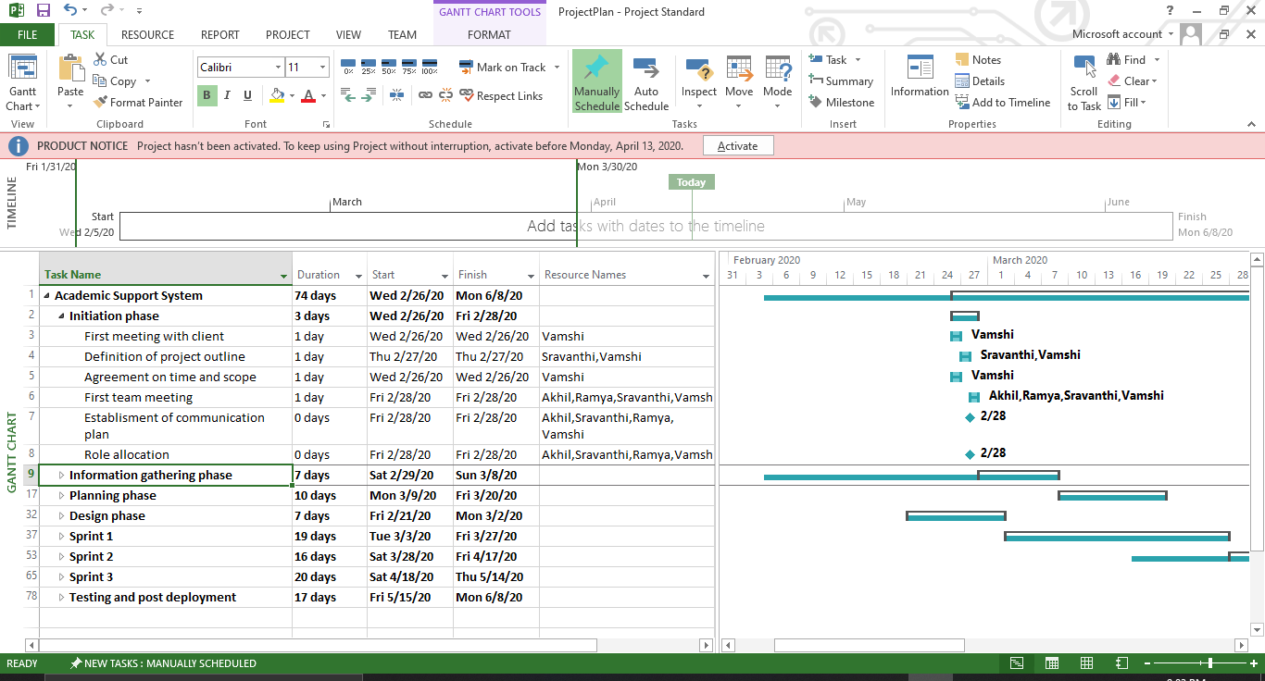

This phase is based on the initial meetings with the client. It consist of getting the project outline from talking with the client what he/she need for the project scope acquiring knowledge from the client about the kind of system he/she need, the establishment of the communication plan with the client and the team members along with role allocation will be done in this phase.

**Information gathering phase:**

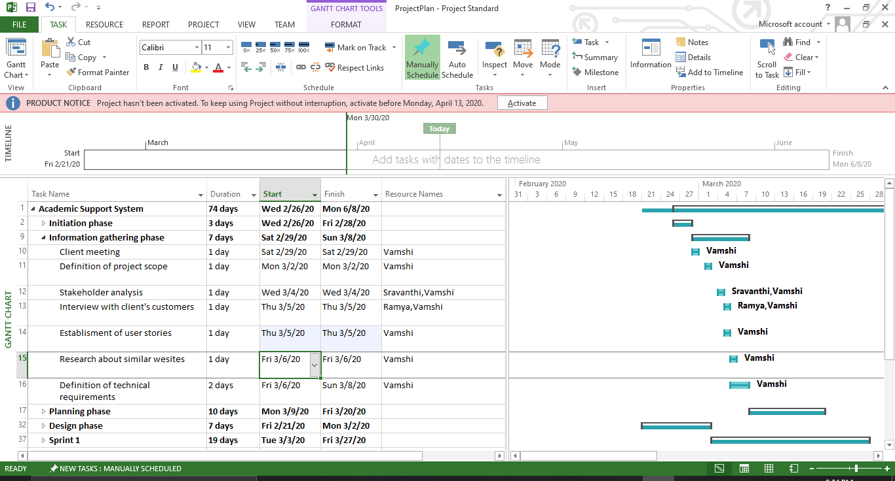

This phase will be based on multiple activities performed by the team. In the starting of the phase a meeting with the client after the meeting the scope of the project is finalized by the project manager. The stakeholder analysis will be done after the finalization of the scope. The customers or the users of the system will be interviewed to get more insight on what kind of people are going to use the system. Research will be done by the project manager checking similar websites that are already created and get an insight on what we are going to create. In the end of this phase the technical requirements will be finalized.

**Planning phase:**

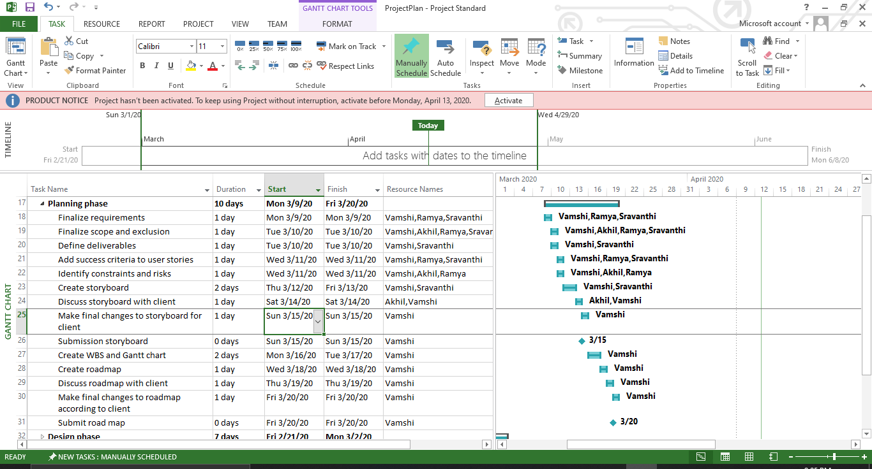

This phase is one of the most important phases of the project development as in this phase all the planning of the project is done. In this phase the requirements, scope and exclusions are finalized by the team. The final deliverables of the project are defined, the acceptance criteria of the user stories and the risks and constraints are defined by the team members. The storyboard of the project is created and submitted to the client, the changes proposed by the client in it are done by the team instantly and final submission of the storyboard is done to the client. The Work Breakdown Structure along with the Gantt chart and the roadmap of the project are created, discussed with the client and the changes proposed by the client and final submission of the roadmap is done in this phase.

**Design phase:**

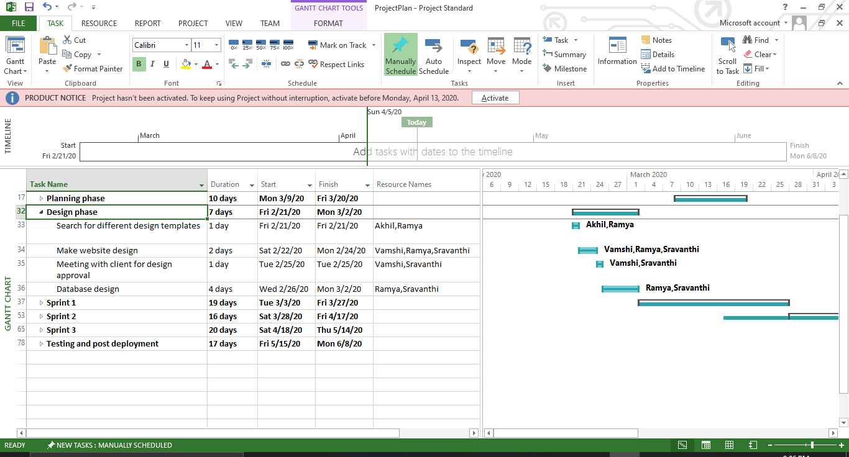

The designing phase of the project consist of limited number of activities including, searching for the design templates, creating the website design and showing the design to the client in a meeting for their approval and the database is also designed in this phase.

**Sprint 1:**

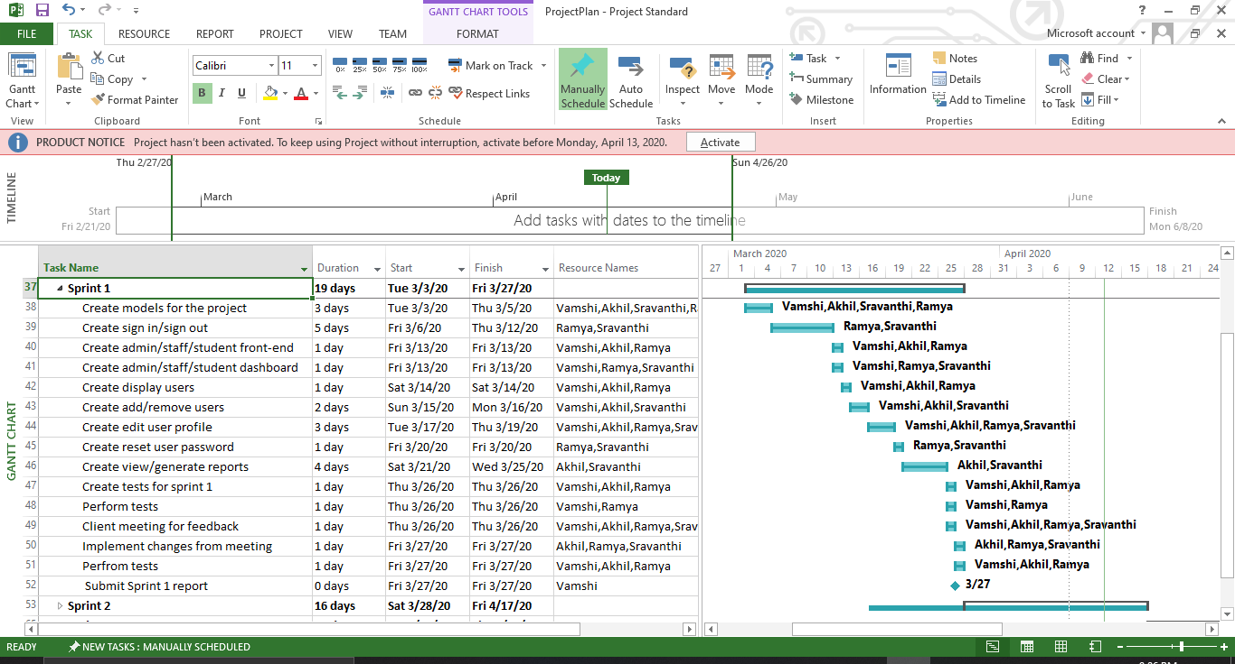

This is the first phase in which the proper programming is being started with creating the project structure including models, controller, repositories and services files are created. After that the sign in functionality with along with its front end is created for each type of user, then the dashboard for admin/academic admin/student are created by the team along with all their front-end requirements. Then all the module for user is developed by the team including the viewing all users, creating new users, editing user profile, deleting a user and the reset user password by the admin is done. This phase majorly focuses on the admin module which also include the generation of reports and viewing them. At the end of the phase the tests for the phase are created and the modules developed in the phase are thoroughly tested. Then the project created till now is presented to client for his/her point of view and the changes he/she wants are noted and done by the team as soon as possible the project is again tested and a report for the phase is submitted.

**Sprint 2:**

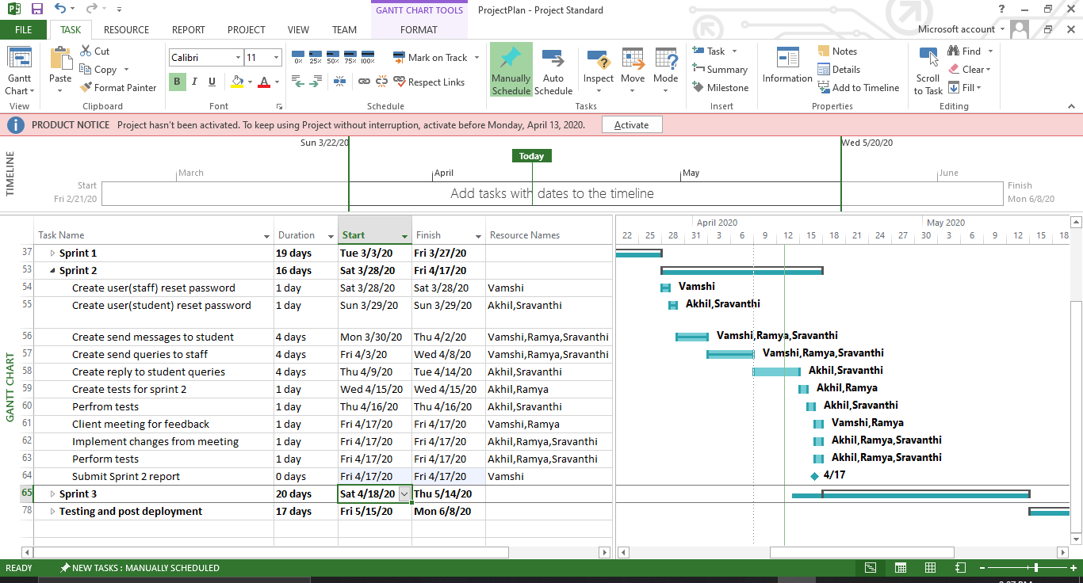

At the starting of the phase the option to reset the password of their own account is developed in the user (academic admin) and user (student) modules. Then the sending message and queries modules are developed in both modules. This phase majorly focuses on the user (academic admin) and user (student) modules. At the end of the phase the tests for the phase are created and the modules developed in the phase are thoroughly tested. Then the project created till now is presented to client for his/her point of view and the changes he/she wants are noted and done by the team as soon as possible the project is again tested and a report for the phase is submitted.

**Sprint 3:**

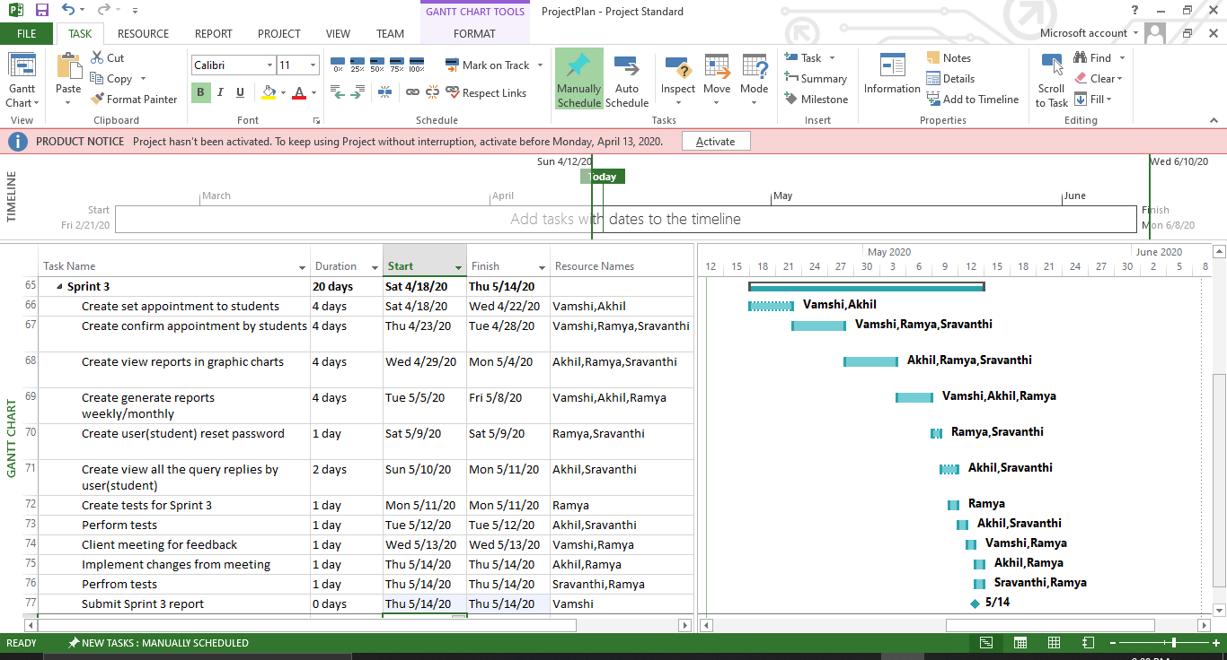

This is the last phase for the programming of the project it is started with creating the appointments module in the project. After that the focus is diverted to the creation of the generate graphical reports by the academic admins and the other remaining functionalities which were not executed properly or left because of the

dependency on other modules are completed in this phase. At the end of the phase the tests for the phase are created and the modules developed in the phase are thoroughly tested. Then the project created till now is presented to client for his/her point of view and the changes he/she wants are noted and done by the team as soon as possible the project is again tested and a report for the phase is submitted.

**Testing and post implementation:**

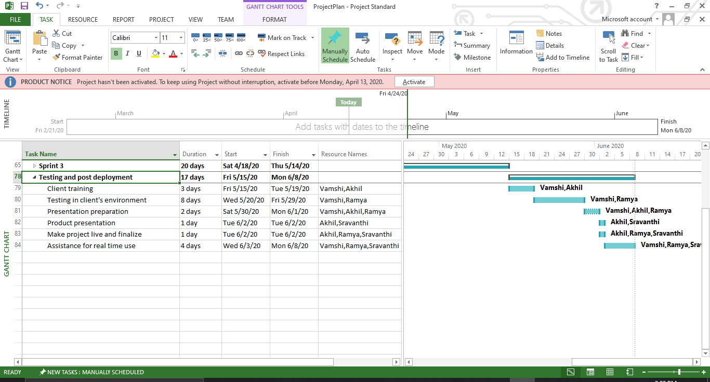

This is the last phase of the project which is the one in which most of the time is spent in interaction with the client and his/her environment. The starting is from the deployment and training of the client which is continued with the creation of a presentation of the project. Then the most important part the part in which the project made live for the users and after that some amount of time will be required according to the deal for the assistance for real time use of the project.